SOFTWARE REQUIREMENTS SPECIFICATION

**MatchMaker**

**Department of Computer Engineering**

**Faculty of Engineering**

**Istanbul Okan University**

**Göktürk Ramazan DOĞAN**

**170212013**

1. Introduction 4

1.1. Title 4

1.2. Purpose of This Report 4

1.3. Scope of This Report 4

2. General Description 5

2.1. Critical Assumption 6

3. Picture of the System, Data Flow 6

4. Data To be Stored 8

5. Functional Requirements 9

5.1. Functional Partitioning 9

5.2. ADD PLAYER 9

5.3. ADD MATCH 9

5.4. ADD FACILITY 9

5.5. EDIT CONTENT 9

5.6. DELETE CONTENT 10

5.7. ADD TEAM 10

5.8. VOTE 10

6. Functional Behaviors 11

6.1. Events, Actions and User Interface 11

6.1.1. Login Screen (Scr 1) 12

6.1.2. Admin Panel Home Page (Scr 2) 12

6.1.3. Admin Panel 'Oyuncular' List Screen (Scr 3) 13

6.1.4. Admin Panel 'Tesisler' List Screen (Scr 4) 14

6.1.5. Admin Panel 'Maçlar' List Screen (Scr 5) 15

6.1.6. Admin Panel 'Oyuncular' Adding Screen (Scr 6) 16

6.1.7. Admin Panel 'Tesisler' Adding Screen (Scr 7) 16

6.1.8. Admin Panel 'Maçlar' Adding Screen (Scr 8) 16

6.1.9. Admin Panel 'Oyuncular' Edit Screen (Scr 9) 17

6.1.10. Admin Panel 'Tesisler' Edit Screen (Scr 10) 17

6.1.11. Admin Panel 'Maçlar' Add Team Screen (Scr 11) 17

6.1.12. Admin Panel 'Maçlar' Vote Screen (Scr 12) 17

7. System Specification 18

7.1. Client 18

7.2. Server 18

7.2.1. Required Software 18

7.2.2. Required Hardware 18

8. Other Non-functional Attributes 19

8.1. Security 19

8.1.1. System Security 19

8.1.2. Network Security 19

8.1.3. User Security 19

9. Validation Criteria 20

10. Function Point Analysis 20

10.1. Total Unadjusted Function Point Calculation 20

10.2. Adjusted Function Point Calculation 22

10.3. Lines of Code Estimation 24

10. Subject INDEX 21

# Introduction

## Title

MatchMaker.

## Purpose of This Report

## This report contains the software contents of the MatchMaker project.

## Scope of This Report

This report describes the functional requirements and behaviour.

# General Description

# The MatchMaker project is a web-based project focused on the two most basic problems experienced in football competition organizations. The first of these is the problem of finding players. In order to solve this problem, the user who is given the administrator right will be able to create a pool of players by adding the information of the football players around him to the database of the project. The powers of the manager will also include functions such as adding matches within the project and adding potential facilities where the matches will be played. In this way, side problems such as finding a facility and setting a match time will also be addressed. Another basic problem is that the teams formed are not equal to each other and therefore the competition and entertainment level of the competition is insufficient. To solve this problem, the project will include a voting system under the authority of the administrator. In this way, after the matches, the manager will be able to rate the players based on his observations in the match, and thus, while forming a team in the next match, he will be able to see their point match their played latly and create an organization with a higher level of competition by evenly distributing the players with high scores.

## Critical Assumption

In this project, it is assumed that the people who are given the management will have an objective approach while voting. In case of abuse, no responsibility is accepted.

# Picture of the System, Data Flow

There are two types of users registered in our system. One of them is the administrative user, which has the authority to add, delete, vote and edit. Another is anonymous users who are not authorized to interact directly with the project's system and database. Anonymous users are not authorized to access the administration panel and the database, they can only see the interface designed for them and the reflection of the information in the database there. Their purpose is only to obtain information about the data in the system.. Context Diagram of Data Flow Diagram is shown in **Figure 1**.

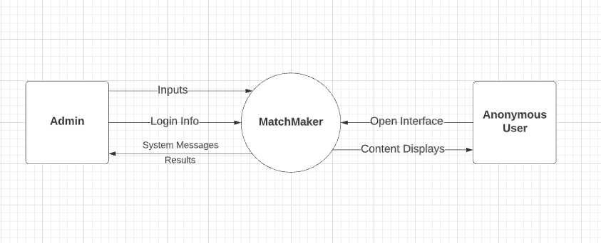

**Figure 1**.

When we look at the function diagram, the connection between the transactions and the database is shown in **Figure 2.** All inputs are taken from the administrator and forwarded to the database.

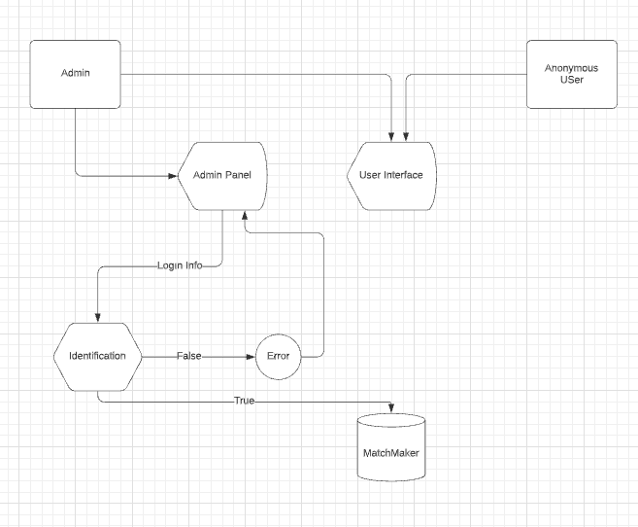

**Figure 2**.

# Data To be Stored

1. As stated in Chapter 2, this database will store data about players, matchers and facilities. Theese informations are football-related data such as the player's contact information, age, profile photo required for profile creation, the foot and position used by the player. For matches theese are teams, date and time. For facilities theese are location, phone number, facility name, field kind and field count.
2. In addition, in order for the system to fulfill its requirements, another type of information that the players must keep apart from their information is the information that will enable the user or users to perform the login function, such as the user name and password of the user or users who are given administrative authority.

# Functional Requirements

## Functional Partitioning

The software of the project includes four different functions. All of these functions are available to the user with administrative authority. These are Add Player, Add Match, Add Facility, Edit Content, Delete Content and Vote.

## 5.2. Add Player

The user, who is given the administrator ID, can enter the information of the players he wants to add to the system through the inputs on the relevant page. The system will create a new row in the players table and save the data entered in the relevant columns.

## Add Match

This function allows the user to create a match by selecting its date, time and facility and then add teams to that match via the required pages.

## Add Facility

Through this function, the administrator user can enter the facilities where future matches will be organized into the system and ensure that they are recorded in the relevant table.

## Edit Content

This function allows the admin user to update or edit the contents of data such as previously logged facilities and players. If it is used, it completes the editing process through the relevant inputs by calling the exact same insertion pages.

## Delete Content

If the administrator decides to delete the previously entered content, he or she can go to the list page of the relevant content and click the button that enables the function to be deleted, thanks to this function.

## Add Team

The administrator can add players in two teams to the matches via this function.

## Vote

This function, which enables the manager to vote for the players who took part in the organized competition after the organized competitions, will only be accessible to the manager users.

# Functional Behaviors

## Events, Actions and User Interface

In this section, the response of the program to all possible inputs and actions of the users as well as user interfaces will be described. The overall process flowchart is

shown in **Figure 5**.

The screens that the user can perform actions are listed below

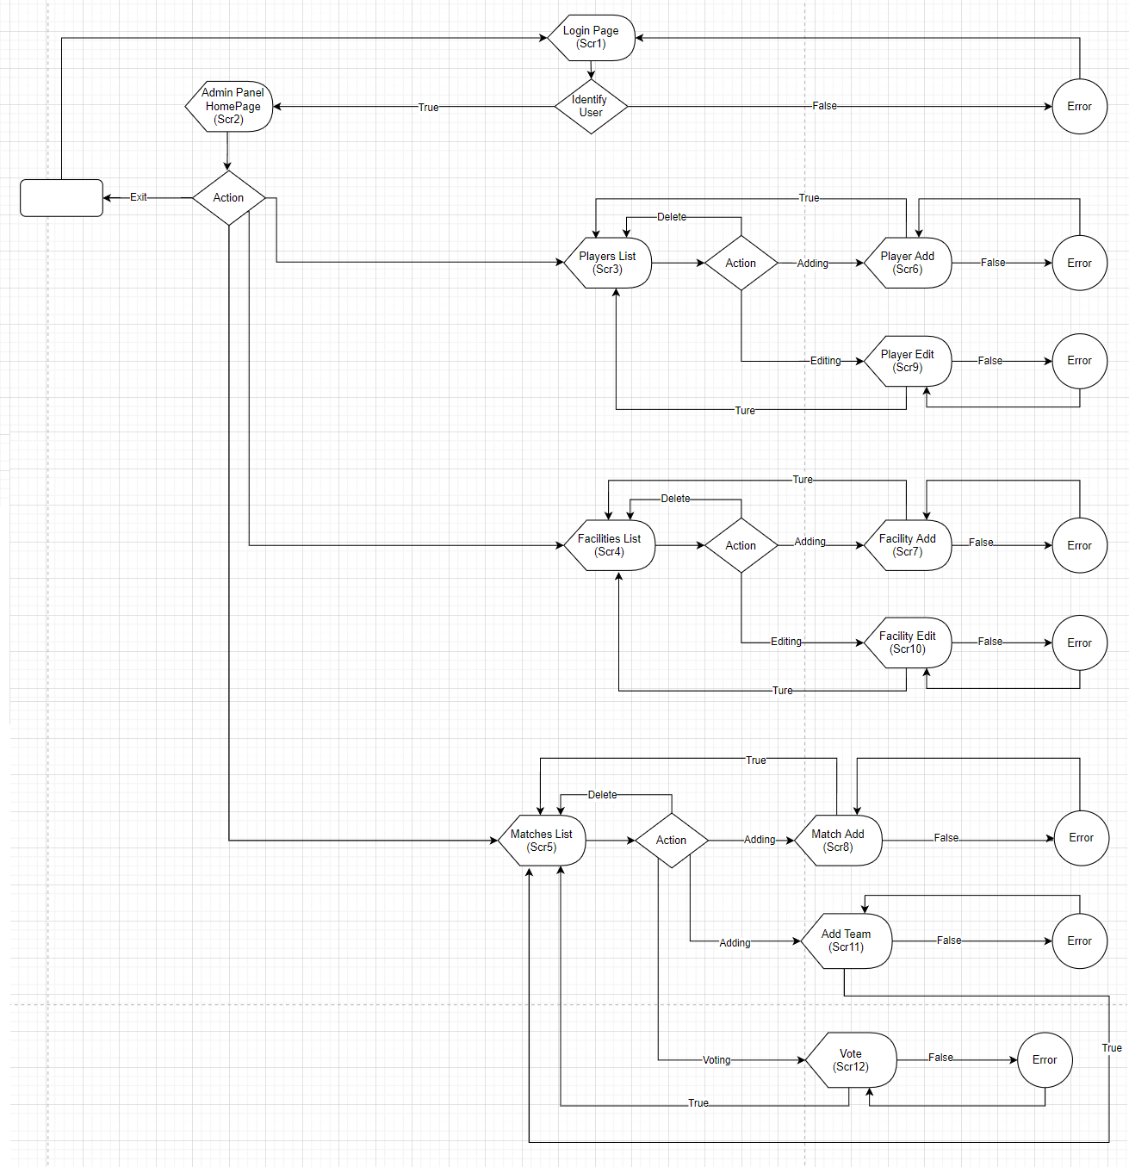

### **6.1.1** **Login Screen (Scr 1)**

If the administration panel is opened, the user will first be greeted by a login form with two inputs, where user name and password entry will be provided.

1. If the login information entered by the user matches the data previously stored in the relevant table in the database, it will direct the user to the homepage of the Administration Panel (Scr 2).
2. If the login information entered by the user does not match the data in the table, a warning will appear that the information entered is incorrect and the user will be redirected to the login page (Src 1).

### **6.1.2 Admin Panel Home Page(Scr 2)**

On this screen of the system, the administrative user is directed to the module adding page that creates a new category, to the list page that displays the contents of the previously created categories, and to the add, delete and edit pages via the list page.

1. By clicking on the name of the category for which the admin user wants to add, edit or delete content, the user can be directed to the page where the contents of the relevant category are listed.
2. The administrator can log out from the administration panel by clicking the ’Çıkış Yap’ button at the bottom of the menu bar. As a result of this action, it is directed to the login page (Src 1) again.

### **6.1.3 Admin Panel ‘Oyuncular’ List Screen(Scr 3)**

On this page of the administration panel, the administrator can view all the players in the category to be listed, together with the preview data.

1. Admin by clicking the ‘Yeni ekle’ button. can go to the relevant page (Scr6) to add a new player.
2. Admin can access the relevant edit page (Scr9) to edit the data of the relevant player by clicking the ‘Düzenle’ button.
3. To delete the player, the administrator user can delete the relevant player from the table in the database by clicking the ‘Kaldır’ button opposite the player. As a result, the administrator will be redirected to the relevant players list page (Scr 3) again.

### **6.1.4 Admin Panel ‘Tesisler’ List Screen(Scr 4)**

On this page of the administration panel, the administrator can view all the facilities in the category to be listed, together with the preview data.

1. Admin by clicking the ‘Yeni ekle’ button. can go to the relevant page (Scr7) to add a new facility.
2. Admin can access the relevant edit page (Scr10) to edit the data of the relevant facility by clicking the ‘Düzenle’ button.
3. To delete the facility, the administrator user can delete the relevant facility from the table in the database by clicking the ‘Kaldır’ button opposite the facility. As a result, the administrator will be redirected to the relevant facility list page (Scr 4) again.

### **6.1.5 Admin Panel ‘Maçlar’ List Screen(Scr 5)**

On this page of the administration panel, the administrator can view all the matches in the category to be listed, together with the preview data.

1. Admin by clicking the ‘Yeni ekle’ button. can go to the relevant page (Scr8) to add a new match.
2. The administrator can switch to the add team page (Scr11) to the relevant match by clicking the ‘Takım A / Takım B’ buttons.
3. By clicking the ‘Oyla’ button, the administrator can switch to the voting page (Scr12) of the relevant match and give points to the players who took part in the match and can enter the scores produced by the teams.
4. To delete the content, the administrator user can delete the relevant content from the table in the database by clicking the ‘Kaldır’ button opposite the match. As a result, the administrator will be redirected to the relevant list page (Src 5) again.

### **6.1.6 Admin ‘Oyuncular’ Adding Screen(Scr 6)**

On this page, the administrator can enter new players into the system. The administrator cannot leave the inputs in the page blank due to the algorithm in which the function is written. These inputs are name, surname, location, phone number, picture, year of birth and the foot he used, respectively. As a result of the process, the user will be redirected to the players list (Src 3) page.

### **6.1.7 Admin ‘Tesisler’ Adding Screen(Scr 7)**

On this page, the administrator can enter new facilities into the system. The administrator cannot leave the inputs in the page blank due to the algorithm in which the function is written. These inputs are facility name, address, site type, phone number, picture, and location, respectively. As a result of the process, the user will be redirected to the facility list (Src4) page.

### **6.1.8 Admin ‘Maçlar’ Adding Screen(Scr 8)**

On this page, the administrator can enter new matches into the system. The administrator cannot leave the inputs in the page blank due to the algorithm in which the function is written. These inputs are date, address, time and facility, respectively. As a result of the process, the user will be redirected to the matches list (Src5) page.

### **6.1.9 Admin Panel Edit ‘Oyuncular’ Screen(Scr 9)**

On this page of the user administration panel, the administrator can edit the data of the relevant player and save it back to the database in an updated way. As a result of this process, it will be redirected to the player list page (Src 3).

### **6.1.10 Admin Panel Edit ‘Tesisler’ Screen(Scr 10)**

On this page of the user administration panel, the administrator can edit the data of the relevant facility and save it back to the database in an updated way. As a result of this process, it will be redirected to the facility list (Src 4) again.

### **6.1.11 Admin Panel ‘Maçlar’ Add Team Screen(Scr 11)**

On this page, the administrator can add players in two teams to the matches and ensure that the data is transmitted to the table where the records of the matches are kept. As a result of this process, it will be redirected to the match list page (Src 5) again.

### **6.1.12 Admin Panel ‘Maçlar’ Vote Screen(Scr 12)**

On this page, the administrator can give points out of 5 to the players who took part in a match that has been added and played before, and can save the scores produced by the teams to the system via inputs. As a result of this process, it will be redirected to the match list page (Src 5) again.

# System Specification

## Client

Although the MatchMaker project is a web-based project. It is recommended to run it in an HTML 5.0 and CSS 3.0 compatible browser. The project does not have any system requirements. For this reason, any device that has an internet connection and supports browser services can access this project without hardware barriers.

## Server

The server to which the project is linked will be kept on the internet, so it is recommended that the users who will access it have a stable internet connection.

### **Required Software**

The server is built on apache server with xampp control panel 3.4 version support. It works with phpMyAdmin version 4.2.

### **Required Hardware**

There is no hardware requirement as the database information will be stored on the internet. 100mb of space on the relevant host will be sufficient.

# Other Non-functional Attributes

## Security

### **System Security**

Database access will be provided only with the username and password to be created by the relevant host, and this information will only be given to administrative users. The default security practices of the phpMyAdmin system will remain in effect.

### **Network Security**

This system, which will work in a local or global network environment, will host a .htaccess application with linking, so it will not receive any attack from the link input. The SSL certificate can then be applied to the site over the host.

### **User Security**

Panel logins are made with user names and passwords. Each administrator ID has its own unique user name and password. It is the responsibility of the administrators to keep them confidential.

# Validation Criteria

Experts Database Software Development Project can be considered to be complete when the following conditions hold:

1. All functional requirements specified in Section 4 are met.
2. All user interfaces that are specified in Section 5 are complete.
3. The program responses to inputs described in Section 5 are as specified.

# Function Point Analysis

## Total Unadjusted Function Point Calculation

**External Inputs**

1. Login Screen **Simple**
2. HomePage **Simple**
3. List Screens **Average**
4. Edit Screens **Simple**
5. Adding Screens **Simple**
6. Vote Screen **Average**

**External Outputs**

1. HomePage **Simple**
2. List Screens **Average**

**File Storage**

1. Information Database **Complex**

**External SW Interfaces**

1. Data transfer interface between web browser and database **Complex**

##### External Query Types

1. Vote **Complex**

|  |  |  |  |  |
| --- | --- | --- | --- | --- |
|  | Weighting Factor | | |  |
| **Measurement Parameter** | **Simple** | **Average** | **Complex** | **Total** |
| External Inputs | **4**\*4= | **2**\*4= | **0**\*6= | **24** |
| External Outputs | **1**\*4= | **1**\*5= | **0**\*7= | **9** |
| File Storage | **0**\*7= | **0**\*10= | **1**\*15= | **15** |
| External SW Interfaces | **0**\*5= | **0**\*7= | **1**\*10= | **10** |
| Count Total | | | | **68** |

## 

## Adjusted Function Point Calculation

The function point count is adjusted for the complexity of the software by assessing each of the answers to the following questions on a scale of 0 to 5.

|  |  |
| --- | --- |
|  | **Fi value** |
| None | 0 |
| Slightly | 1 |
| Present | 2 |
| Medium level | 3 |
| Important | 4 |
| Vital | 5 |

|  |  |  |
| --- | --- | --- |
| 1. Data Communications | Vital | **5** |
| 2. Distributed Processing | None | **0** |
| 3. Performance Requirements | Important | **4** |
| 4. Operational Configuration Load | None | **0** |
| 5. Transaction Rate | Medium level | **3** |
| 6. Online Data Input | Medium level | **3** |
| 7. End User Quality | None | **0** |
| 8. Online File Update | Important | **4** |
| 9. Algorithmic Complexity | Slightly | **1** |
| 10. Reusability | None | **0** |
| 11. Ease of Installation | Slightly | **1** |
| 12. Operational Ease | Slightly | **1** |
| 13. Multi-site System | None | **0** |
| 14. Maintainability | Medium level | **3** |
|  | TOTAL | **25** |

These 14 complexity adjustment values are summed to give the value of Σ (*Fi*).

**Σ (*Fi*) = 25**

**Adjusted Function points** = Count Total * (0.65 + 0.01 * Σ (*Fi*))

=64*0.9 = **58.5.**

## Lines of Code Estimation

The total adjusted function points came out to be 45.9 for the Experts’ Database. For estimating lines of code we can use the **Table 1** below.

|  |  |  |
| --- | --- | --- |
| Language | (Albrecht 1983) | (Low & Jeffery 1990) |
| COBOL | 110 LOC / FP | 106 LOC / FP |
| PL / 1 | 65 LOC / FP | 80 LOC / FP |
| 4 GL | 25 LOC / FP | 40 LOC /FP |

Table 1: Estimated LOC for each FP.

|  |  |  |
| --- | --- | --- |
| Language | LOC(Albrecht 1983) | LOC(Low & Jeffery 1990) |
| COBOL | **58.5**\*110=6435 | **58.5**\*106=6201 |
| PL / 1 | **58.5**\*65=3803 | **58.5**\*80=4680 |
| **4 GL** | **58.5*25=1463** | **58.5*40=2340** |

**Table 2: LOC calculation.**

For 4GL, the results are came up to be **1463 LOC** according to Albrecht 1983 and **2340 LOC** according to Low & Jeffery 1990.

**Subject Index**

D

Data Flow Diagram

Level 1 6

Data To be Stored 8

F

Function

Add Player 9

Add Facility 9

Add Match 9

Edit Content 10

Delete Content 10

Add Team 10

Vote 10

Function Point (FP) Analysis

Adjusted FP Calculation 21

Lines of Code Estimation 22

Total Unadjusted FP Calculation 20

S

System Specification 18

Security

Network 19

System 19

User 19

U

User Interface

Screen

Login 12

Home Page 12

Player List 13

Facility List 14

Match List 15

Adding Player 16

Adding Facility 16

Adding Match 16

Edit Player 17

Edit Facility 17

Add Team 17

Vote 17

V

Validation Criteria 20